MEDICAL IMAGE SEGMENTATION
WITH DEEP LEANING

Crisan Paul UTCN
Teodor

I. Project description

Segmentation of medical images using Deep Learning. You are given medical images taken during an operation. Segment the image pixels into different classes: tissue, instrument, blood vessels etc. The dataset contains training data labels which can be used to train a neural network: https://www.kaggle.com/datasets/newslab/cholecseg8k

II. Introduction

Medical image segmentation plays a crucial role in various healthcare applications, allowing accurate identification and isolation of specific regions of interest within an image. Deep Learning techniques, particularly Convolutional Neural Networks (CNNs), have shown remarkable success in automatic image segmentation tasks.
After extensive research about image segmentation, I have found out about a particular type of CNN that excels in solving our particular task: the UNet architecture. UNet has gained significant popularity in the field of medical image segmentation due to its exceptional performance and ability to accurately segment various anatomical structures with great precision.
Before going any further, it's worth mentioning the meaning of the word “feature” in the context of our problem; "features" refer to the learned representations of the input image at different levels of abstraction.

Here is a brief description of the UNet architecture, it's key components and it's objective:
- Contracting Path (Encoder):
Uses convolutional layers and downsampling to capture highlevel features. Reduces spatial dimensions.
- Expanding Path (Decoder):
Employs upsampling and skip connections. Restores spatial resolution.
Combines lowlevel and highlevel features.
- Skip Connections (Crop):
Connects corresponding layers between the contracting and expanding paths. Fuses lowlevel and highlevel features.
- Training Objective:
Minimizes a suitable loss function, such as crossentropy or dice coefficient. Compares predicted segmentation with ground truth labels.
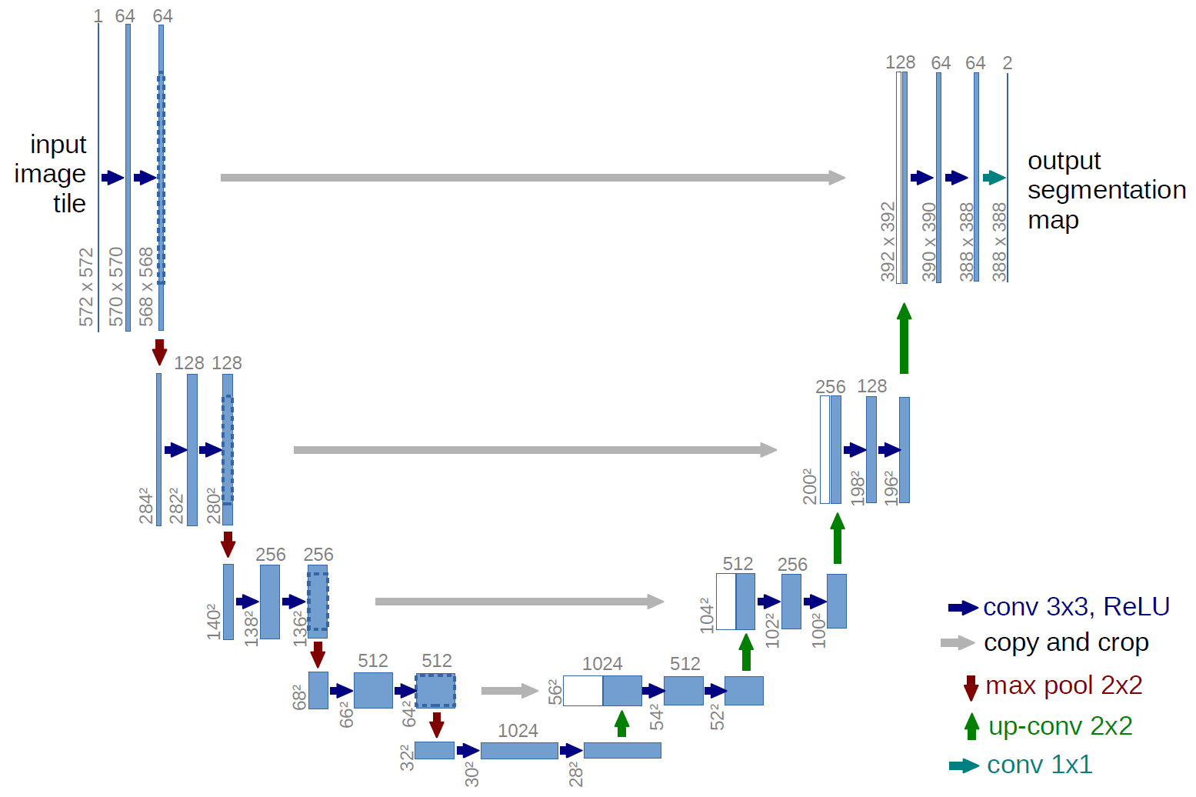

Basic UNet example

III. Implementation

In this section, I will describe the stepbystep implementation process for the segmentation of medical images using the UNet architecture. The framework I will be using will be PyTorch in PyCharm.

I. Dataset Preparation
CholecSeg8K dataset uses the endoscopic images from Cholec80, which is provided by Research Group CAMMA (Computational Analysis and Modeling of Medical Activities), as the base. The research group cooperated with the University Hospital of Strasbourg, IHU Strasbourg, and IRCAD to construct the dataset. Cholec80 contains 80 videos of cholecystectomy surgeries performed by 13 surgeons. Data in CholecSeg8K Dataset are grouped into a directory tree for better organization and accessibility. Each directory on the first level tree represents the video clips extract from Cholec80 and is named by the filename of the video clips. Each directory on the secondary level tree store the raw image data, annotation, and color masks for an 80 frame video clip. The frames are extracted and placed into directories, each containing 80 consecutive frames of the video with a resolution of 854x480 and the annotated semantic segmentation masks. There are a total of 101 directories and the total number of frames is 8080. The total number of classes of different objects is 13, including black background, abdominal wall, liver, gastrointestinal tract, fat, grasper, connective tissue, blood, cystic duct, L hook electrocautery (Instrument), gallbladder, hepatic vein, and liver ligament. In this dataset, not all 13 would appear in the same frame at the same time.
However, the initial organization of the dataset may not be ideal for the segmentation task. To facilitate data processing, it is necessary to store all the input images and corresponding masks in separate folders, ensuring a consistent and convenient format for further implementation and training.
Here we have a code snippet from organizer.py, which is a python script that solves the data organization problem:
# From >
SOURCE = os.path.join("medical_data")
# To <
DESTINATION_IMAGES = os.path.join("train", "images")
DESTINATION_MASKS = os.path.join("train", "masks")
# Navigate parent directory
for folder in os.listdir(SOURCE):
path = os.path.join(SOURCE, folder)
# Navigate child directories
for sub_folder in os.listdir(path):
path2 = os.path.join(path, sub_folder)
image_dir = os.listdir(path2)
# Get image and mask names from each folder
images = [image for image in image_dir[::4]]
color_masks = [image for image in image_dir[1::4]]
# Iterate both lists at the same time
for image, mask in zip(images, color_masks):
# From >
src_img_path = os.path.join(path2, image)
src_mask_path = os.path.join(path2, mask)
# To <
dst_img_path = os.path.join(DESTINATION_IMAGES, image)
dst_mask_path = os.path.join(DESTINATION_MASKS, mask)
# Copy images
shutil.copy(src_img_path, dst_img_path)
shutil.copy(src_mask_path, dst_mask_path)

In the upcoming sections, we will discuss the dataset preprocessing steps required to prepare the images and masks for training the UNet model.

II. Dataset Preprocessing
In order for the data to be processed correctly by the model, we need to create a PyTorch Dataset class and override the __getitem__ method. This allows us to customize the data loading and transformation process for training the UNet model effectively.
Firstly, we need to store the image paths, mask paths and the transformations we will be applying to the images.
class SegmentationDataset(Dataset):
def __init__(self, imagePaths, maskPaths, transforms):
# Store the image and mask filepaths, and transformations
self.imagePaths = imagePaths
self.maskPaths = maskPaths
self.transforms = transforms

Secondly, we override the __getitem__ method, in which we apply the right transformations to the images.
def __getitem__(self, idx):
# Grab the image and mask paths from the current index
imagePath = self.imagePaths[idx]
maskPath = self.maskPaths[idx]
# Load the image from disk, swap its channels from BGR to RGB,
# and read the associated mask from disk
image = cv2.imread(imagePath)
image = cv2.cvtColor(image, cv2.COLOR_BGR2RGB)
mask = cv2.imread(maskPath, cv2.IMREAD_GRAYSCALE)
mask = cv2.resize(mask, (config.INPUT_IMAGE_WIDTH, config.INPUT_IMAGE_HEIGHT),
interpolation=cv2.INTER_NEAREST)
# Masks are scaled to [0, 12] because we have to predict 13 classes
mask = (mask / 255.0 * (config.NUM_CLASSES1)).round().astype('uint8')
if self.transforms is not None:
# Apply the transformations to both image and its mask
image = self.transforms(image)
mask = torch.from_numpy(mask).long()
# return a tuple of the image and its mask
return image, mask
When considering the transformations used in the preprocessing stage, it is worth addressing a potential point of confusion. One might wonder why the input image and the output mask cannot be treated and processed in the same way. The answer lies in the nature of the output mask, which, in theory, is not an image but rather a tensor representation of class labels. To ensure compatibility with the model's architecture and loss function, we follow a distinct transformation procedure for the output mask. Initially, the mask is treated as a grayscale image. We then normalize its values within the range of [0, 12], which aligns with the 13 classes we are working with. This normalization ensures that the mask reflects the appropriate class distribution during training and evaluation. Finally, the mask is transformed into a tensor format, allowing for seamless integration into the deep learning pipeline.

III. UNet Model Implenetation
1. UNet class:
- Consists of an encoder, a decoder, and a regression head.
- The encoder extracts features from the input image, and the decoder upsamples and combines these features to generate the final segmentation map.
- The regression head produces the segmentation map based on the features from the decoder.
- The class provides a forward method that performs the forward pass of the UNet model.
class UNet(Module):
def __init__(self, encChannels=(3, 16, 32, 64),
decChannels=(64, 32, 16),
nbClasses=config.NUM_CLASSES, retainDim=True,
outSize=(config.INPUT_IMAGE_HEIGHT, config.INPUT_IMAGE_WIDTH)):
super().__init__()
# Initialize the encoder and decoder
self.encoder = Encoder(encChannels)
self.decoder = Decoder(decChannels)
# Initialize the regression head and store the class variables
self.head = Conv2d(decChannels[-1], nbClasses, 1)
self.retainDim = retainDim
self.outSize = outSize
def forward(self, x):
# Grab the features from the encoder
encFeatures = self.encoder(x)
# Pass the encoder features through decoder
decFeatures = self.decoder(encFeatures[::-1][0],
encFeatures[::-1][1:])
# Pass the decoder features through the regression
map = self.head(decFeatures)
# Check to see if we are retaining the original
if self.retainDim:
map = F.interpolate(map, self.outSize)
# Return the segmentation map
return map

2. Block class:
- The 'Block' class represents a basic building block used in the encoder and decoder modules of the UNet architecture.
- It consists of two convolutional layers and a ReLU activation function.
- The forward method applies the convolutional layers and the activation function to the input tensor.
class Block(Module):
def __init__(self, inChannels, outChannels):
super().__init__()
# Store the convolution and RELU layers
self.conv1 = Conv2d(inChannels, outChannels, 3)
self.relu = ReLU()
self.conv2 = Conv2d(outChannels, outChannels, 3)
def forward(self, x):
# Apply CONV => RELU => CONV block to the inputs and return it
return self.conv2(self.relu(self.conv1(x)))

3. Encoder class:
- It consists of multiple blocks, where each block processes the input and reduces the spatial dimensions using convolutional layers.
- Max pooling is applied after each block to downsample the features.
- The forward method performs the forward pass through the encoder blocks and returns the intermediate outputs.
class Encoder(Module):
def __init__(self, channels=(3, 16, 32, 64)):
super().__init__()
# Store the encoder blocks and maxpooling layer
self.encBlocks = ModuleList(
[Block(channels[i], channels[i + 1])
for i in range(len(channels) - 1)])
self.pool = MaxPool2d(2)
def forward(self, x):
# Initialize an empty list to store the intermediate outputs
blockOutputs = []
# Loop through the encoder blocks
for block in self.encBlocks:
# Pass the inputs through the current encoder block, store
# the outputs, and then apply maxpooling on the output
x = block(x)
blockOutputs.append(x)
x = self.pool(x)
# Return the list containing the intermediate outputs
return blockOutputs

4. Decoder class:
- It consists of upsampling blocks and decoder blocks.
- Upsampling blocks increase the spatial dimensions of the input tensor.
- Encoder features are cropped and concatenated with the upsampled tensor to recover spatial resolution and combine highlevel and lowlevel features.
- The forward method performs the forward pass through the decoder blocks and returns the final decoder output.
- The purpose of the crop function is to ensure that the encoder features align properly with the upsampled tensor in terms of spatial dimensions.
class Decoder(Module):
def __init__(self, channels=(64, 32, 16)):
super().__init__()
# Initialize the number of channels, upsampler blocks, and decoder blocks
self.channels = channels
self.upconvs = ModuleList(
[ConvTranspose2d(channels[i], channels[i + 1], 2, 2)
for i in range(len(channels) - 1)])
self.dec_blocks = ModuleList(
[Block(channels[i], channels[i + 1])
for i in range(len(channels) - 1)])
def forward(self, x, encFeatures):
# Loop through the number of channels
for i in range(len(self.channels) - 1):
# Pass the inputs through the upsampler blocks
x = self.upconvs[i](x)
# Crop the current features from the encoder blocks,
# Concatenate them with the current upsampled features,
# and pass the concatenated output through the current decoder block
encFeat = self.crop(encFeatures[i], x)
x = torch.cat([x, encFeat], dim=1)
x = self.dec_blocks[i](x)
# return the final decoder output
return x
def crop(self, encFeatures, x):
# grab the dimensions of the inputs, and crop the encoder
# features to match the dimensions
(_, _, H, W) = x.shape
encFeatures = CenterCrop([H, W])(encFeatures)
# return the cropped features
return encFeatures

IV. Model Training
First, the dataset is prepared by loading the file paths for the images and masks from the specified dataset directories. The data is then split into training and testing sets using the train_test_split function from the 'sklearn.model_selection' module. The training and testing file paths are separated accordingly, and the testing image paths are saved to a text file for future reference.
# Load the image and mask filepaths
imagePaths = sorted(list(paths.list_images(config.IMAGE_DATASET_PATH)))
maskPaths = sorted(list(paths.list_images(config.MASK_DATASET_PATH)))
# Partition the data into training and testing splits
split = train_test_split(imagePaths, maskPaths,
test_size=config.TEST_SPLIT, random_state=42)
(trainImages, testImages) = split[:2]
(trainMasks, testMasks) = split[2:]
print("[INFO] saving testing image paths...")
f = open(config.TEST_PATHS, "w")
f.write("\n".join(testImages))
f.close()

Next, the data loading and transformation steps are performed. Transformations are defined using 'torchvision.transforms.Compose' to convert the images to PIL format, resize them to the desired input size, and convert them to tensors. The 'SegmentationDataset' class is used to create PyTorch datasets for both the training and testing sets. This class applies the defined transformations to the image and mask pairs. Data loaders are then created using 'torch.utils.data.DataLoader' for efficient batch processing of the data during training.
# Define transformations
transformations = transforms.Compose([transforms.ToPILImage(),
transforms.Resize((config.INPUT_IMAGE_HEIGHT,
config.INPUT_IMAGE_WIDTH)),
transforms.ToTensor()])
# Create the train and test datasets
trainDS = SegmentationDataset(imagePaths=trainImages, maskPaths=trainMasks,
transforms=transformations)
testDS = SegmentationDataset(imagePaths=testImages, maskPaths=testMasks,
transforms=transformations)
print(f"[INFO] found {len(trainDS)} examples in the training set...")
print(f"[INFO] found {len(testDS)} examples in the test set...")
trainLoader = DataLoader(trainDS, shuffle=True,
batch_size=config.BATCH_SIZE, pin_memory=config.PIN_MEMORY,
num_workers=os.cpu_count())
testLoader = DataLoader(testDS, shuffle=False,
batch_size=config.BATCH_SIZE, pin_memory=config.PIN_MEMORY,
num_workers=os.cpu_count())

The UNet model is initialized using the 'UNet' class, and it is moved to the specified device. The loss function is defined as the cross-entropy loss using 'torch.nn.CrossEntropyLoss()'. The Adam optimizer is used to update the parameters of the UNet model.
# Initialize UNet model
unet = UNet().to(config.DEVICE)
# Initialize loss function and optimizer
lossFunc = CrossEntropyLoss()
opt = Adam(unet.parameters(), lr=config.INIT_LR)

The CrossEntropyLoss function is widely used as a loss function in classification tasks, including image segmentation. It measures the dissimilarity between the predicted class probabilities and the true class labels. In the context of image segmentation, each pixel is assigned a class label, and the goal is to predict the correct class label for each pixel. The Adam optimizer adapts the learning rate for each parameter based on the magnitude of its gradients and the exponential moving average of past gradients. This adaptive learning rate helps the optimizer converge quickly and effectively to the optimal set of parameters.

The training loop begins by iterating over the specified number of epochs ('config.NUM_EPOCHS'), in our case 40 epochs is enough, more than that could lead to overfitting. For each epoch, the UNet model is set to training mode, and the total training and validation losses are initialized. The training data is looped over using the training data loader, and for each batch, the input and target tensors are moved to the device. The forward pass is performed on the UNet model to obtain the predicted outputs. The training loss is calculated using the predicted outputs and the target tensors. The optimizer is updated by zeroing the gradients, performing backpropagation, and taking a step, this updates the model's parameters based on the calculated gradients and the optimization algorithm . The training loss is accumulated.
It is worth talking a little bit about gradients.Gradients in the context of deep learning and neural networks are like arrows that show us the way to improve our model. They provide information about the direction and steepness of the slope in the loss function, which measures how well the model is performing. By following the gradients, we can adjust the model's parameters in a way that helps us reduce the loss and make the model better at its task. Gradients guide us in the right direction to improve the model's performance.
for e in tqdm(range(config.NUM_EPOCHS)):
unet.train()
# Initialize the total training and validation loss
totalTrainLoss = 0
totalTestLoss = 0
# Loop over the training set
for (i, (x, y)) in enumerate(trainLoader):
# Send the input to the device
(x, y) = (x.to(config.DEVICE), y.to(config.DEVICE))
# Perform a forward pass and calculate the training loss
pred = unet(x)
loss = lossFunc(pred, y)
opt.zero_grad()
loss.backward()
opt.step()
# Add the loss to the total training loss so far
totalTrainLoss += loss
with torch.no_grad():
# Set the model in evaluation mode
unet.eval()
# Loop over the validation set
for (x, y) in testLoader:
# Send the input to the device
(x, y) = (x.to(config.DEVICE), y.to(config.DEVICE))
# Make the predictions and calculate the validation loss
pred = unet(x)
totalTestLoss += lossFunc(pred, y)
# Calculate the average training and validation loss
avgTrainLoss = totalTrainLoss / trainSteps
avgTestLoss = totalTestLoss / testSteps
# Update our training history
H["train_loss"].append(avgTrainLoss.cpu().detach().numpy())
H["test_loss"].append(avgTestLoss.cpu().detach().numpy())

After the training loop, the model is set to evaluation mode using 'unet.eval()'. The validation data is looped over using the testing data loader, and for each batch, the input and target tensors are moved to the device. The forward pass is performed on the UNet model to obtain the predicted outputs. The validation loss is calculated using the predicted outputs and the target tensors. The average training and validation losses for the epoch are calculated.
The training history is updated with the average losses. The training and validation information for the epoch is printed, displaying the epoch number, train loss, and test loss. Finally, the total time taken for training is displayed. The training loss is plotted using 'matplotlib.pyplot' and saved to a file. The trained model is serialized and saved to disk using 'torch.save'.

IV. Development and Testing

It is important to note that this model builds upon existing knowledge and research in the field of image segmentation. During the initial stages of this project, while exploring resources on image segmentation, I came across a simple UNet model specifically designed for binary, low-resolution, grayscale image segmentation. This served as the foundational inspiration for my model and proved to be a valuable time-saving resource. Let’s talk about the development process.

Humble beginnings – 15-05-2023
First and foremost, it is essential to highlight the significant differences in image pre-processing for our specific case. Unlike the original implementation, our project deals with high-resolution RGB images. To align with the requirements of our model, the input images undergo a transformation, resizing them to 256x256 dimensions. This adjustment is necessary to accommodate the increased computational resources required.
In regards to the mask, a separate set of operations is applied. The mask is also resized to 256x256 dimensions and subsequently normalized within the interval of [0, 12]. This normalization ensures that each pixel value in the mask corresponds to its respective class. To establish the mask as a proper output image, it is further processed by rounding each pixel value to the nearest integer. This step ensures that the mask maintains its class representation accurately. Finally, the processed mask is converted into a long tensor, ensuring compatibility with the model's requirements for the output format.
The testing loop is an essential component for evaluating the trained model's performance. It involves displaying the original image, the ground truth mask, and the predicted mask. First, the pre-trained UNet model is loaded and set to evaluation mode. The test image and mask file paths are obtained, and a test dataset is created with the defined transformations.
Within the testing loop, each test example is processed. The input image is converted to a format suitable for display. The predicted mask is extracted from the model's output and normalized. The ground truth mask is also prepared for visualization. The predicted mask is colorized using class labels and colors defined in the configuration.
Using Matplotlib, the input image, ground truth mask, and predicted mask are displayed side by side. The loop pauses and waits for user input before showing the next image. This interactive visualization allows for a visual assessment of the model's performance.

The first model - Average IoU ≈ 0.13
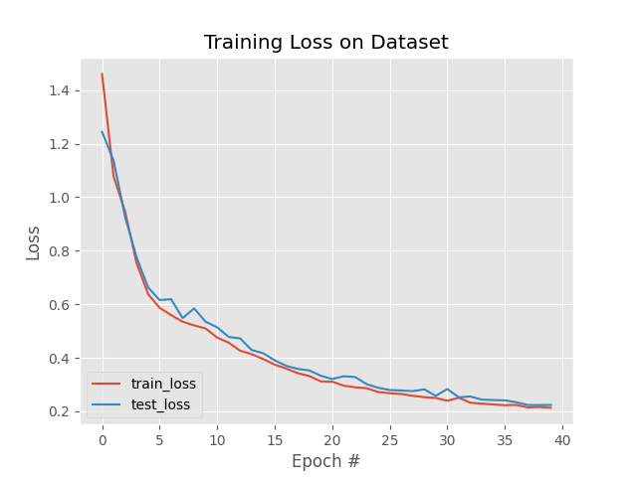
The initial model was trained on my laptop's i7 CPU, which presented certain limitations due to the nature of Python as a dynamically typed language. Multi-threading was challenging to implement, resulting in the training process utilizing a single thread. Consequently, training the complex model on this configuration took approximately 12 hours. It is important to note that the initial model was trained with 11 classes, despite the intended 13 classes (I can’t count). Despite these limitations, the model's complexity remained relatively low when considering the subsequent improvements in the architecture, as evident in the configuration settings: encChannels=(3, 16, 32, 64), decChannels=(64, 32, 16).
The graph depicted here illustrates the progression of training and testing loss across 40 epochs. It is noteworthy to observe the substantial reduction in loss during the initial 10 epochs, indicating a favorable trend. However, towards the latter 10 epochs, we can observe a plateauing effect in the loss reduction. This stagnation suggests that further increasing the number of epochs may lead to overfitting of the model, wherein it becomes excessively specialized to the training data and fails to generalize well to new, unseen data. From the graph, we can infer that the choice of the cross-entropy loss function and Adam optimizer was appropriate.
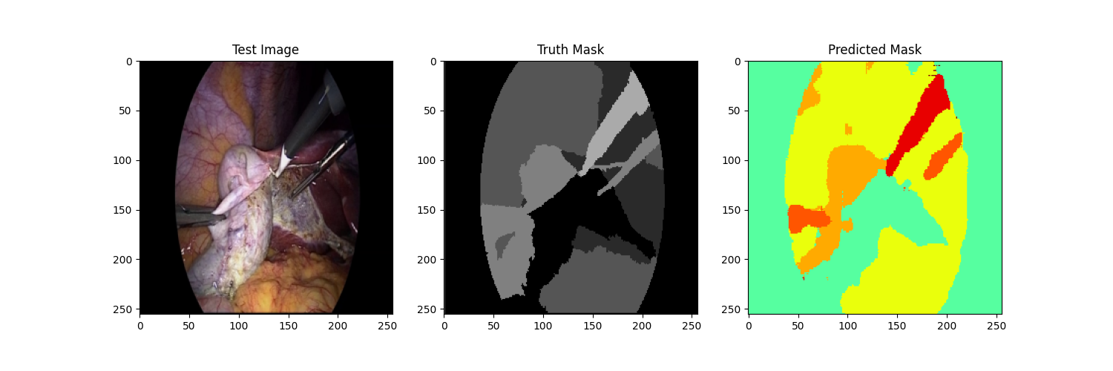
In the output plot we got from the testing loop, it's pretty clear that the predicted mask is way off the mark. It's definitely not accurate enough for any medical purposes. It seems like the model we used for this problem isn't complex enough to handle the intricacies involved. We need to make some serious improvements and tweaks to the model's architecture and training approach if we want to get better results that are actually useful in the medical field.

Bringing out the big guns - 17-05-2023

I didn’t think this project would be so captivating and that I would fully dedicate to it, but here I am. I “borrowed” an Ethereum miner from my dad, he calls it the BMF (Big Motherfucker). Let’s talk about the BMF for a second: It has an AMD Ryzen 5 2600 CPU with 3.60 GHz and a 16 GB of RAM, but this is irrelevant to out problem. What interests us, is that fact that the BMF is stacked with 4 monster GPUs: 1 x NVIDIA RTX 2060, 2 x NVIDIA GTX 1060 SUPER and 1 x NVIDIA GTX 1060. All of these total at around 70 teraflops of deep learning horse power. Time to tune the model into oblivion.

I used Microsoft's Remote Desktop Connection (RDC) to connect to the BMF back home, which was used exclusively for Ethereum mining. However, configuring PyTorch with CUDA turned out to be quite a challenge. My dad had made some modifications to the Windows settings to optimize mining efficiency, which caused some issues during the configuration process. It took me a good two days to troubleshoot and resolve these problems, but now everything is set. Training the same model on the new computer, using just the RTX 2060 took aprox. 30 minutes.

The second model - Average IoU ≈ 0.75
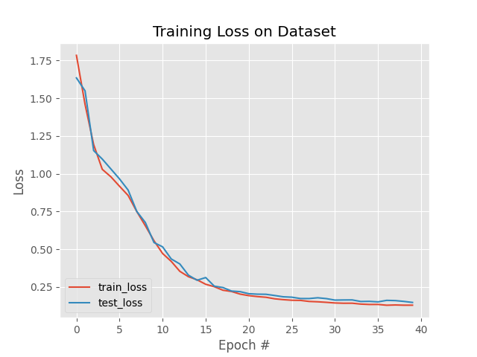
I bumped up the complexity of the model and also used the right number of classes: encChannels = (3, 32, 64, 128, 256), decChannels=(256, 128, 64, 32), NUM_CLASSES = 13.

In this graph, we can observe a significant reduction in both the training and testing loss during the final epoch when compared to the previous model.

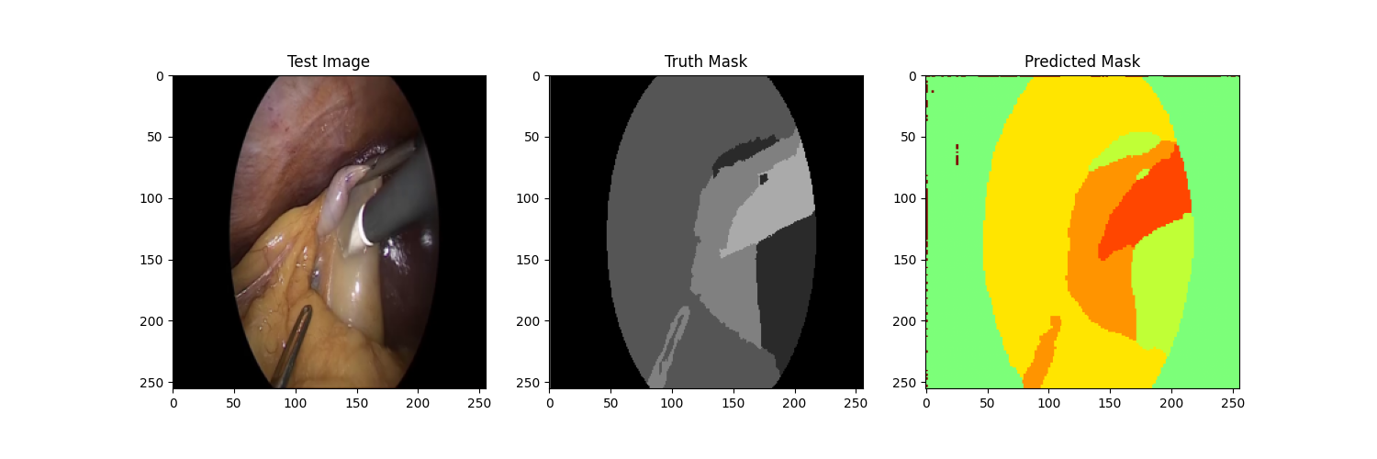
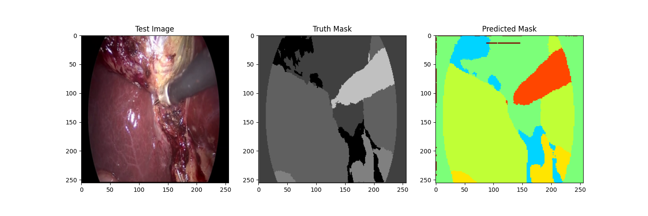
By taking a closer look at the plots, we can clearly see that the model's accuracy has significantly improved. It is now capable of capturing even the smallest details in the images, showcasing a remarkable enhancement in performance.
However, these improvements are still not sufficient. In my next attempt, I will focus on further increasing the accuracy by not only refining the model but also increasing the dimensions of the images and masks. This adjustment is essential because in the medical field, working with 256x256 images is not practical or representative of real-world scenarios.

Hyperparameter tuning - 18-05-2023

During my experimentation with the model's parameters, I encountered a limitation when attempting to further increase the width or height of the model. This resulted in the GPUs running out of CUDA memory. It became evident that the current model I am using is not memory-efficient. While this issue poses no problem for the RTX 2060 GPU, the bottleneck arises with the GTX 1060 GPU. Therefore, I need to find a solution that allows me to save memory during network training, even if it comes at the expense of increased computational costs.
I found some techniques that could help me with the memory efficiency problem, like gradient checkpointing or mixed precision training. However, before I start implementing features I have no idea about, it's a good idea to analyze the CUDA memory usage during training using PyTorch Profiler. This will give me a clear understanding of how much computation and memory my model requires. It will help me figure out where the bottlenecks are and guide me in optimizing memory usage.
I created a script called profiler.py that records the CPU and GPU memory activity during training and saves it in a text file. This allows me to analyze the resource utilization of my model. In the future, I plan to implement TensorBoard for visualization purposes. But for now, I have the the answers.

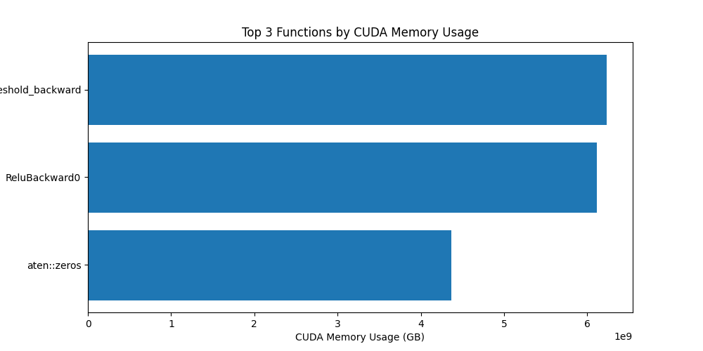
I conducted a CUDA memory usage analysis of the PyTorch functions and discovered that the functions involved in backward propagation consume the most memory. It is evident that employing the gradient checkpointing technique would be a viable solution to address this issue, allowing me to further upscale the model. However, it is important to note that this technique comes with the drawback of increased computational cost. Instead of storing the gradients in GPU memory, they are recomputed during the backward propagation process.

Bibliography
https://pytorch.org/tutorials/beginner/deep_learning_60min_blitz.html
https://viso.ai/deep-learning/image-segmentation-using-deep-learning
https://www.hindawi.com/journals/jhe/2022/9580991/
https://pyimagesearch.com/2021/11/08/u-net-training-image-segmentation-models-in-pytorch/

